**45. Pipelines**

--- **tree**

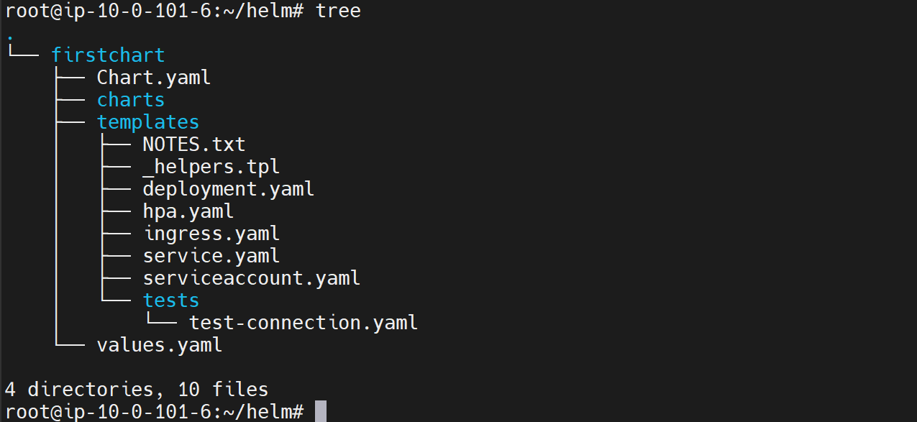

--- cat deployment.yml

apiVersion: apps/v1

kind: Deployment

metadata:

  name: {{ include "firstchart.fullname" . }}

  labels:

    {{- include "firstchart.labels" . | nindent 4 }}

spec:

  {{- if not .Values.autoscaling.enabled }}

  replicas: {{ .Values.replicaCount }}

  {{- end }}

  selector:

    matchLabels:

      {{- include "firstchart.selectorLabels" . | nindent 6 }}

--- **note** - pipe symbol. you will find it in several places in the deployment.yml and other template files as well. So, this pipeline allows us to chain multiple expressions, commands, or function calls.

--- **note** - The output of this function on the left will be passed as it input to that function on the right side.